**question-1:**

Write a program which will find all such numbers which are divisible by 7 but are not a multiple of 5, between 2000 and 3200 (both included). The numbers obtained should be printed in a commaseparated sequence on a single line.

**Solution:**  nl=[] for x in range(1500, 2701): if (x%7==0) and (x%5==0):

nl.append(str(x))

print (','.join(nl))

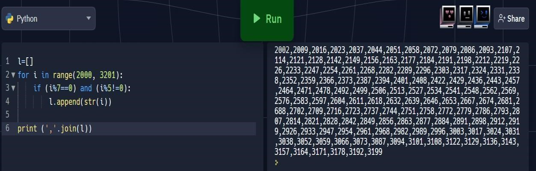

**Question-2:**

With a given integral number n, write a program to generate a dictionary that contains (i, i*i) such that is an integral number between 1 and n (both included). and then the program should print the dictionary.

Suppose the following input is supplied to the program:

8

Then, the output should be:

{1: 1, 2: 4, 3: 9, 4: 16, 5: 25, 6: 36, 7: 49, 8: 64}

**Solution:**

number = int(input("Type a number: "))

numberDict = {}

for i in range(1, number+1):

numberDict[i] = i*i

print(numberDict)

